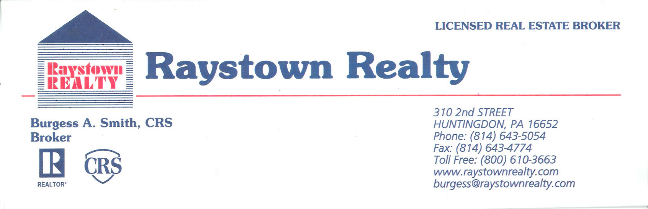
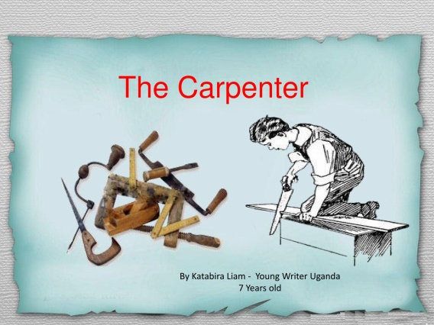

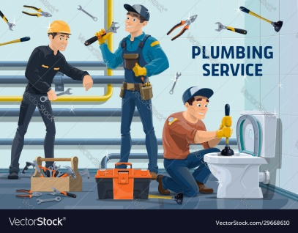

Service Provider Information and Disclaimer The following of tradesmen is furnished to you for your convenience in assisting you in the repairs/modifications of your property. The companies and individuals randomly listed below are considered to be reputable with the real estate industry but are in no way endorsed, nor are their services or prices warranted or guaranteed in any manner whatsoever by Raystown Realty, Inc. or the sales associate working with you.

Cleaning Services | Junk Outs | Electricians | Plumbers | Specialty Work
Clean Freaks 814-386-5006 | Todd Lemin (814) 599-5077 |  | Austin Smith 814-506-5128 | Midstate Seamless Gutters ((717) 248-2237
JoJo Cleaning Services (814) 251-6005 | David Beatty 814-644-0038 (H) or 814-599-4876 © | Kann Electric (814) 386-9069 | Fred Hess 814-599-7960 | Rick Worthy (Gutters) (814-(814) 643-6953
Dirtbusters  (814) 949-9027 |  | D.C. Goodmans 814-643-2322 | D.C. Goodmans 814-643-2322 | Bange Masonry ((814) 695-0583
 |  | Burkeys Electric HVAC (814) 644-3185 | Rebenstein HVAC and Plumbing (Williamsburg) 814-944-9703 | Central Sealcoating ((877) 819-7325
 |  | Allied HVAC/Electric (814) 643-2645 | Jordan Price (814) 907-2134 or (814) 643-1243 | K & K Sealcoating (814) 251-2193
 |  | Brennenan Mechancials (814) 643-2645 |  | D.R. Eriksen Well and Pumps Service (814) 658-3639
 |  | Steve Kritz (814) 448-3595 |  | Runks Water Service(814) 599-1889
 |  | Jim Decker ((814) 599-0835 |  | E.B. Enders (Custom Cabinets) (814) 6431860
 |  | Dysart Electric (717) 599-8889 |  | Jeff Tate Paving (814) 819-6110
 |  |  |  | Mountain Air Garage Doors (814) 447-3560
 |  |  |  | Walters Well Drilling/Water Treatment (814) 259-3985.
 |  |  |  | Stakes Tree Service (814) 644-8437
 |  |  |  | Walters Well Drilling/Water Treatment (814) 259-3985.

Contractors Remodeling | Contractors Remodeling – Cont | Contractors Remodeling – Cont) | HVAC | Bldg Supplies
Josh Williams (814) 641-1316 | Bob Reynolds (814) 932-7142 | Kincel Home Improvements ((814) 386-5392 | Burkey Mechanicals (HVAC) (814) 6434-3185 | Mt Union Lumber ((814) 542-9631
Smitty’s Contracting LLC (717) 487-6588 | Cisney and O’Donnel (814) 643-4968 | Bafia Builders ((814) 599-0999 | Brenneman Mechanicals (HVAC) (814) 251-2244 | Your Building Center (814) 643-0782
Rowe Construction (814) 542-9820 | Confer Custom Homes ((814) 669-1332 | D&A Construction LLC (814) 599-9216 | Heeters HVAC (814) 669-9332 | 84 Lumber (814) 643-7284
Tim McGraw (814) 599-5010 | Valley Construction (814) 669-4942 |  | Berrena (HVAC) (814) 643-2645 | Fike Bros Carpet (814) 644-7948
Lewis Bros (814) 643-1092 | Wensel General Contracting (814) 448-2046 |  | Bliss Repair and Installation 814-345-0825 | Magoos Carpet (814) 643-5393
J. Porter Enterprises 814.819.0037 | Scott Wright Builders (814) 448-2046
Helsel Contracting (814) 251-5563 | Casey McGraw (814) 599-9825
Bones (Bathroon Remodeling – Construction (814) 599-5261 | Mark Moore (814) 599-7716
John Miller (Raystown Handiman) (814) 907-2249 | K.L. Mills (944) 447-3644
Bob Mansberger (Cassville) (814) 448-2013 | J. D. Yingling Construction (814) 599-7297
Marlin Hunsicker (James Creek) (814) 251-2197 | Lewis Bros (814) 643-1092

Handyman Services | Excavators | Septic Repair/Install | Roofing | Surveyors
John Miller (814) 907-2249 | Runks Diggen & Haulen (814) 693-5378 | Lakes Septic | Affordable Roofing (814) 643-3312 | A to Z Land Consultant (814) 809-3025
Homeworks Handiman (814) 506-6088 | Hawn Excavating (814) 669-4255 | Coffee Run (Andy Keith) (814) 644-1482 | Kish Valley Roofing  (717) 935-2908 | Mitch Neuter (814) 635-4020
 | P&J Excavating (Orbisonia) (814) 447-9025 | Boozel Septic Systems (814) 599-5077 | Peachy’s Roofing  (717) 363-7701 | Africa Eng (814) 643-0710
 | J. Porter Enterprises (814) 669-4160) |  | J & J Roofing (717) 483-6306 | John Young 814) 644-6882
 | Peterson Excavating (Burnt Cabin Area) (717-729-8312

